Village of Homer
Climate Action Plan
2019
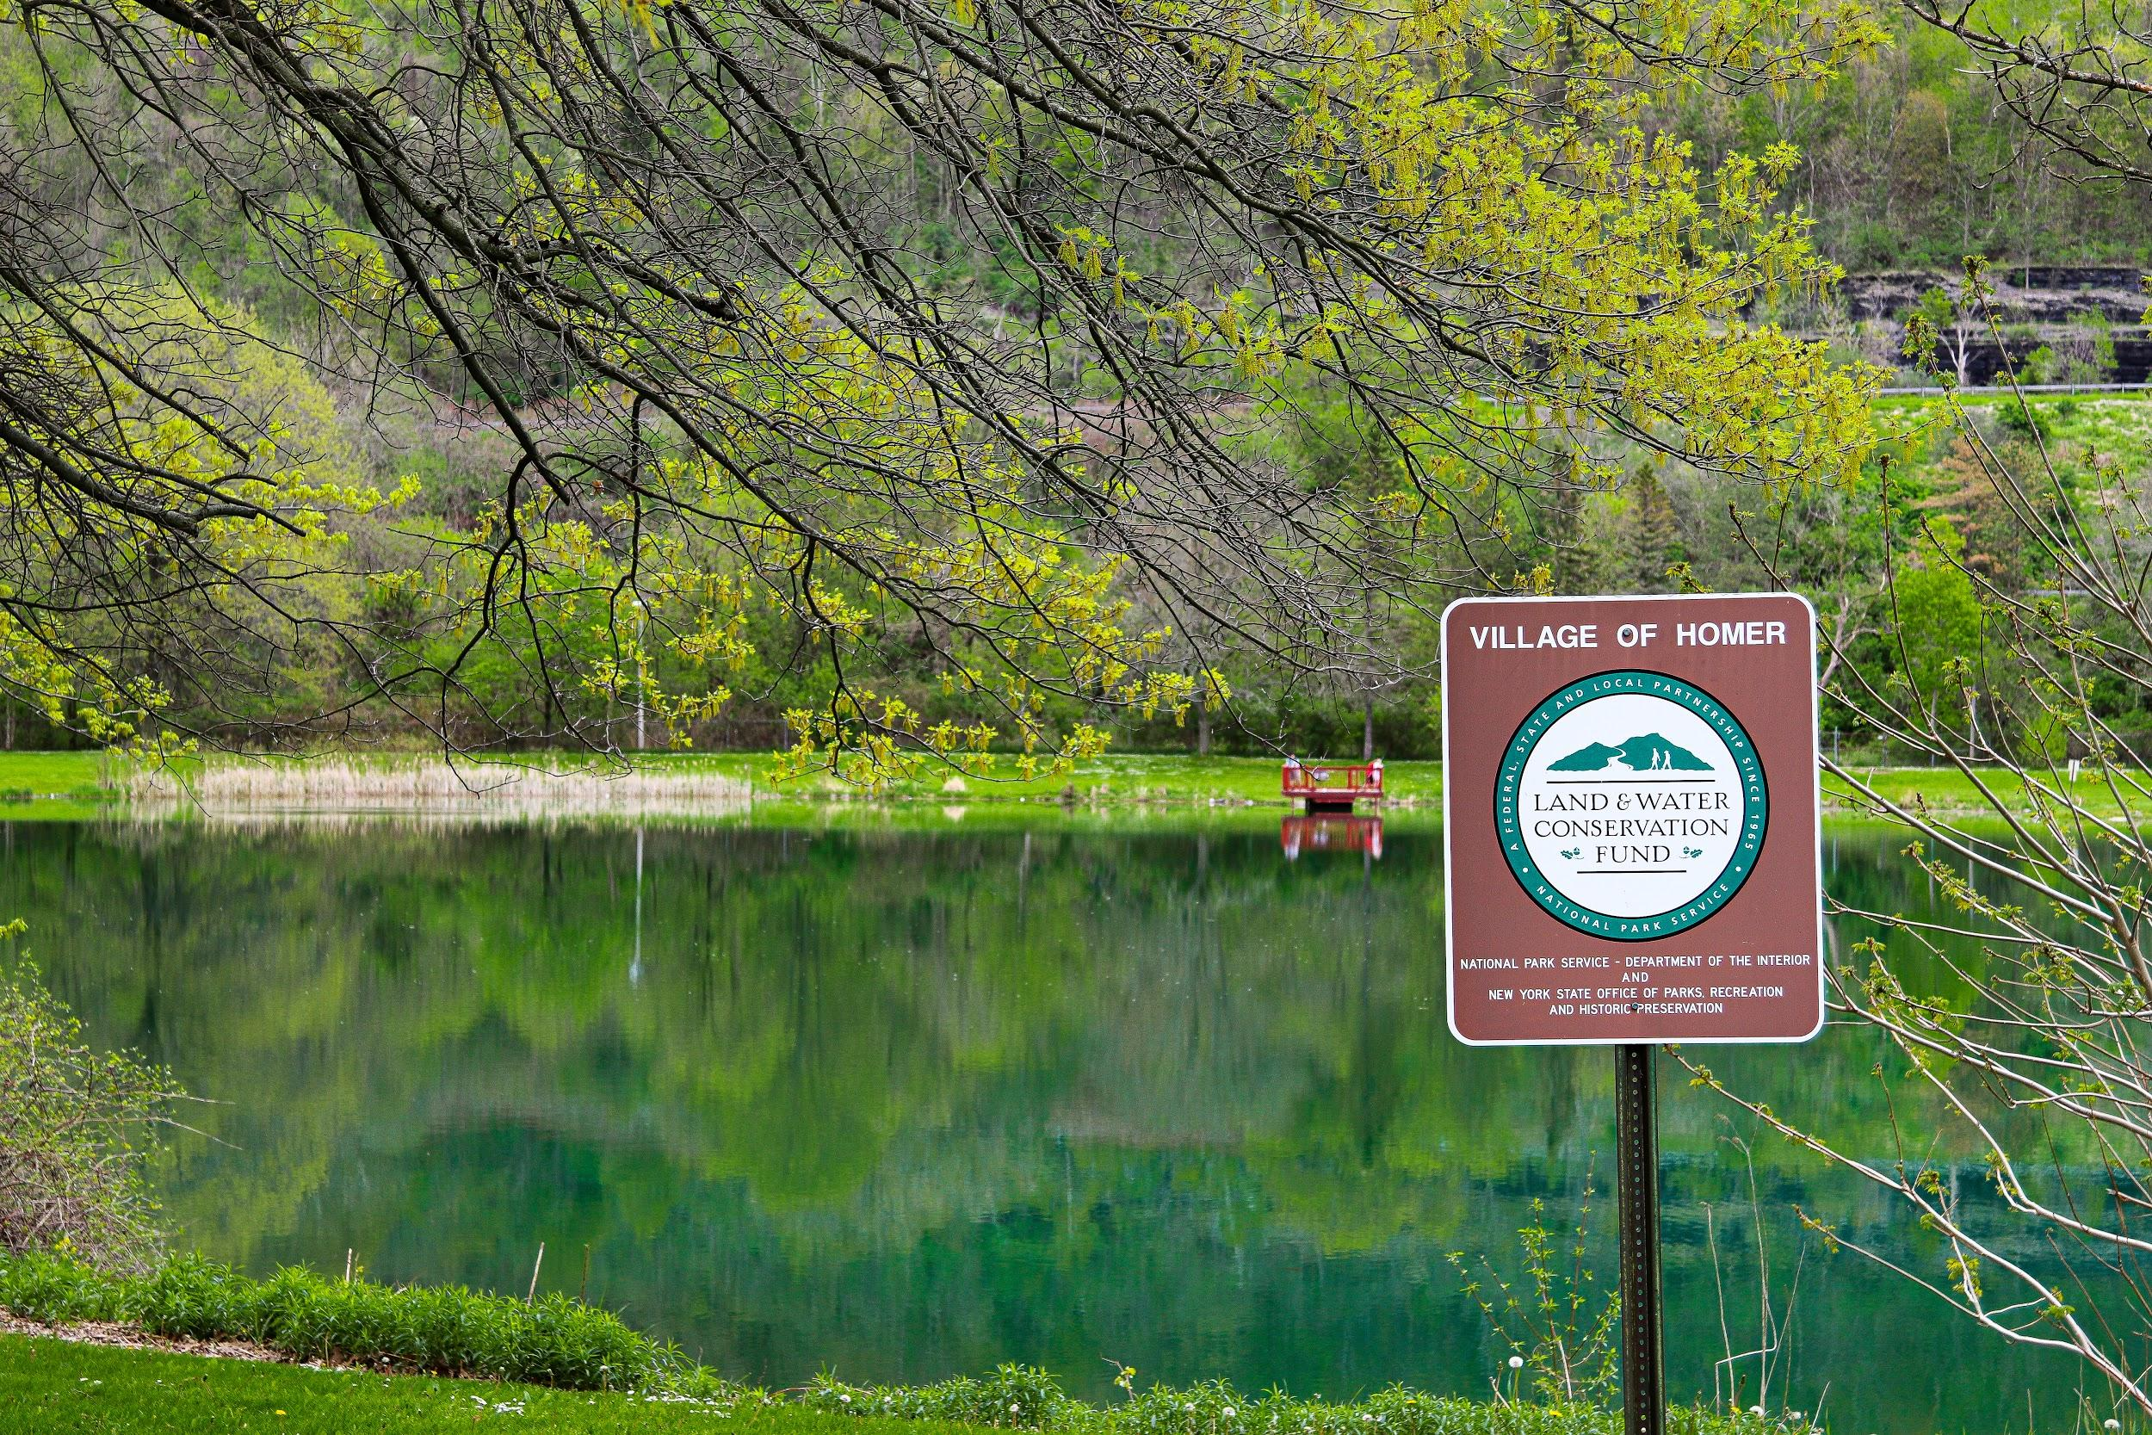
By: Shenequa Perry, Andrew Fagerheim, and Sean Vormwald
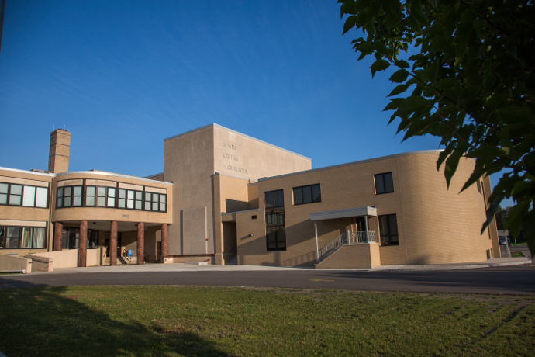
Reviewed by the Task Force

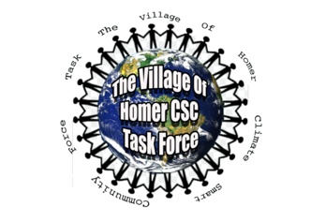
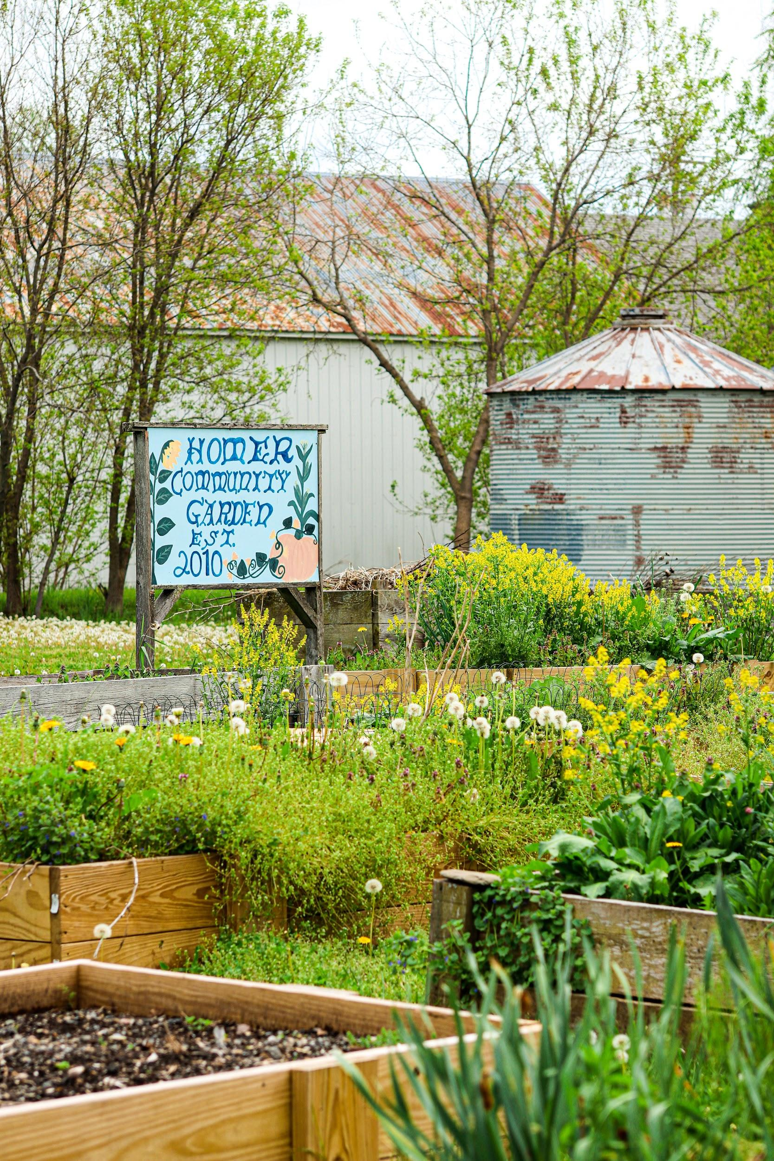
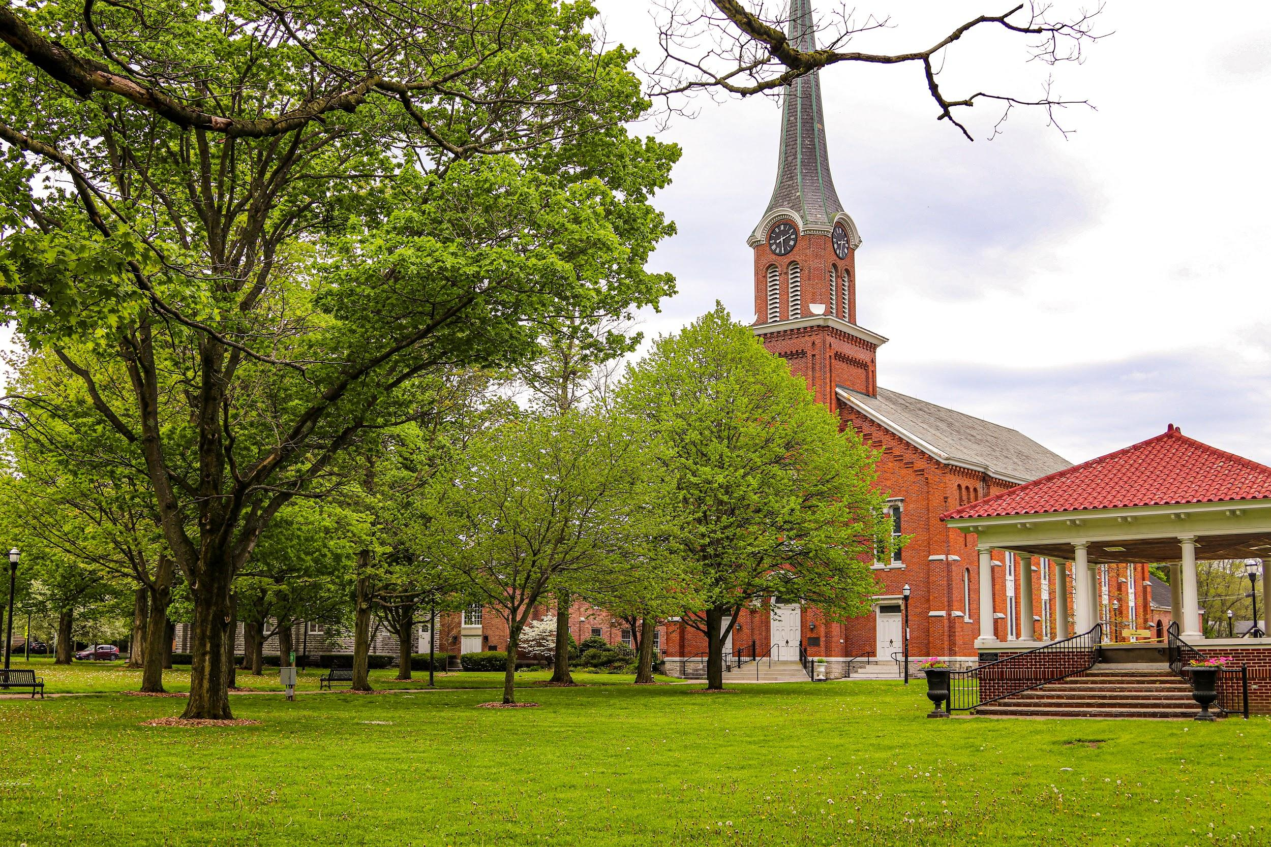
Introduction to the Village of Homer and the Climate Smart Communities Task Force

Welcome to the Village of Homer! In this report you will have the opportunity to learn more about our village and how we are working to make it more sustainable. Homer is a rural community of about 3,000 residents located in Central New York. The village government consists of a mayor and clerk who fulfill the executive role and a village board who serves as the legislative body. The village provides a variety of services to its residents through departments such as: the Water Department, the Parks and Recreation Department, the Glenwood Cemetery, the Department of Public Works, the Police Department, and the Fire Department.
In 2018 the Village of Homer Board passed a resolution recognizing the importance of taking municipal action to address climate change and joining the New York State Climate Smart Communities program. Through the Climate Smart Communities program the Village of Homer pledged to reduce greenhouse gas emissions and adapt to a changing climate through the following actions:
- Build a climate-smart community
- Inventory emissions, set goals, and plan for climate action
- Decrease energy use
- Shift to clean, renewable energy
- Use climate-smart materials management
- Implement climate-smart land use
- Enhance community resilience to climate change
- Support a green innovation economy
- Inform and inspire the public
- Engage in an evolving process of climate action
The Village of Homer established a Climate Smart Communities task force to assist Mayor Hal McCabe and village staff with implementing the various elements of the Climate Smart Communities program. The task force is comprised of Mayor McCabe, village board members, village residents, and Homer high school students.
Our task force has pioneered an innovative way to achieve the requirements of the CSC program. We have given youth a voice in this process by giving the leadership role of the task force to the Homer Environmental Club of which the CSC Coordinator and Assistant Coordinator have both been members. We believe climate change will have drastic impacts upon the future of our village and that young people should have the ability to shape how we respond.
The Village of Homer has been committed to environmental excellence even before participating in the Climate Smart Communities (CSC) program. The village board approved energy efficiency upgrades to municipal buildings, fixed a water main break that decreased the amount of water distributed, and became a Clean Energy Community. We are excited about continuing this legacy by pursuing bronze level certification within the Climate Smart process by reducing our greenhouse emissions and adapting to a changing climate.

Results from the Greenhouse Gas Inventory

Village Government Operations Inventory
A group of students at the State University of New York College of Environmental Science and Forestry (ESF) completed a preliminary greenhouse gas emission inventory for Village of Homer municipal operations as part of a class assignment. The inventory examined greenhouse gas emissions associated with the village government’s electricity, natural gas, gasoline, and diesel fuel consumption for the various village departments. The inventory found that the Village of Homer government operations contributed to 517 MTCO2e in 2017.

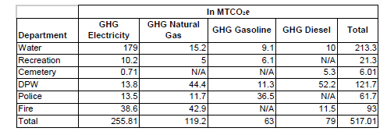
Table 1
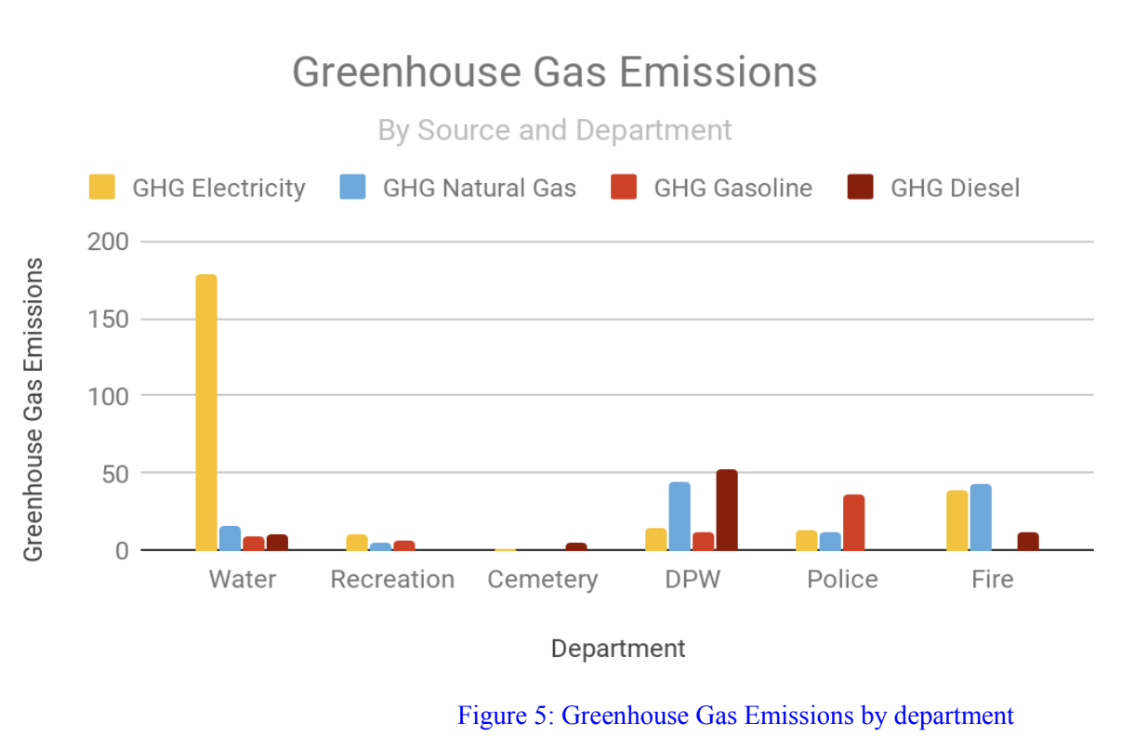
Figure 1
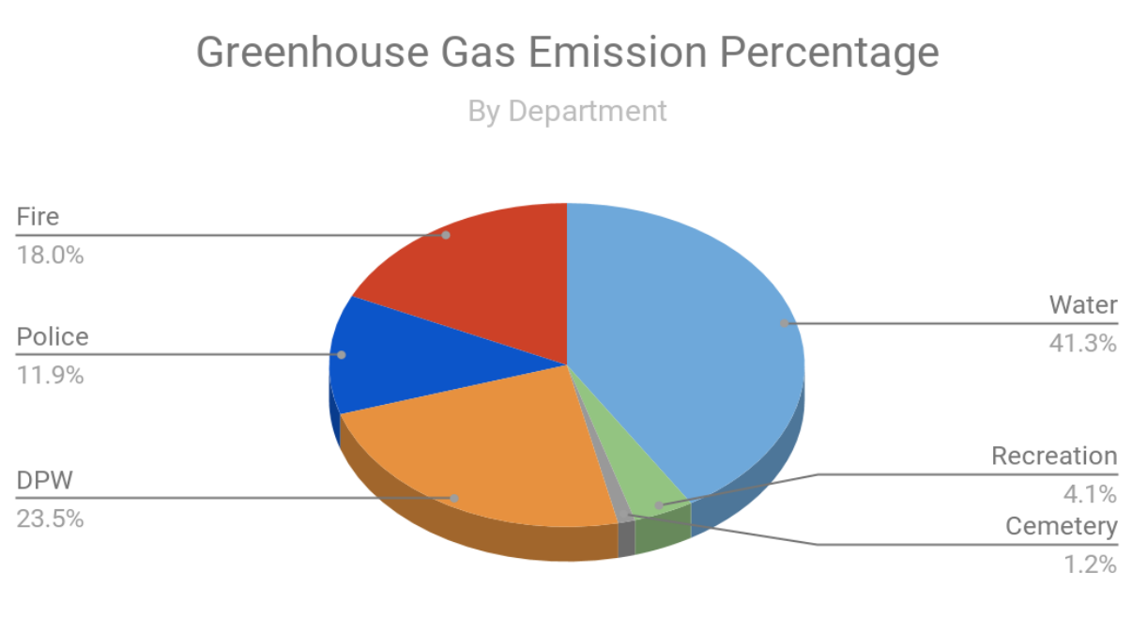
Figure 2
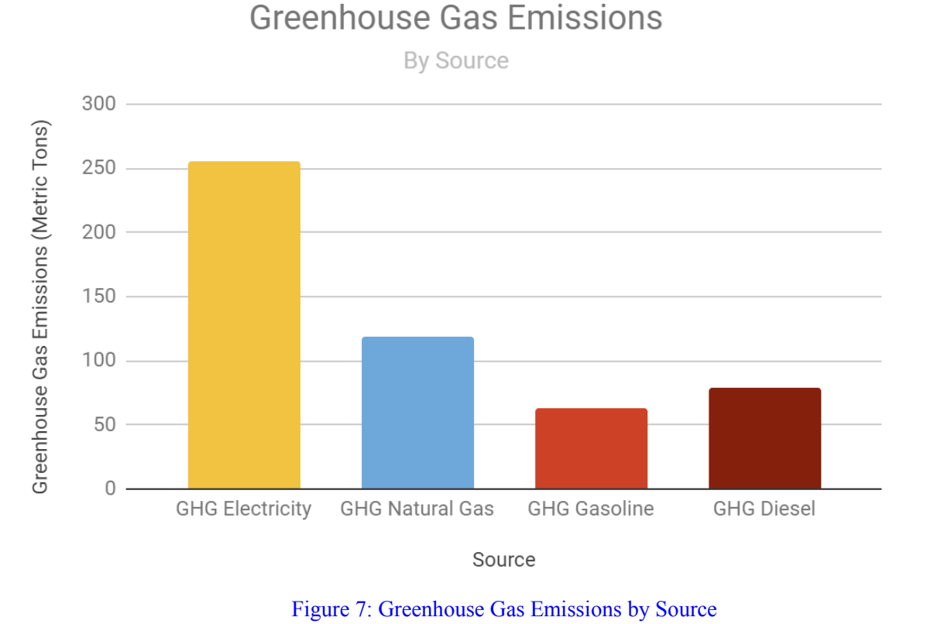
Figure 3

This greenhouse gas emissions inventory shows the emissions from the Village of Homer’s public services departments. The inventory also shows the fuel sources causing the emissions. The fuel sources and consumption vary by department. The varying consumption can be explained by the function of each department. Public safety operates a fleet of police and fire vehicles, consuming 4,101.62 gallons of gasoline in 2018. The public safety department is also a large consumer of diesel, at 1,132.94 gallons of diesel. The public safety department contains fire trucks, responding to calls across a 125 square mile district, which are responsible for diesel emissions. The water department uses a large amount of electricity to power water pumps throughout the village. Public works consumed 5,145.03 gallons of diesel in 2018 to fuel their 4 CDL class 8 trucks, used to keep the roads clear of snow and haul asphalt for paving. Public works natural gas consumption can be attributed to heating of their large garage and office building. Public works also consumes a nominal amount of gasoline to fuel two F-250 support trucks and a Ventrac lawn mower used to cut grass.

Government Energy Costs
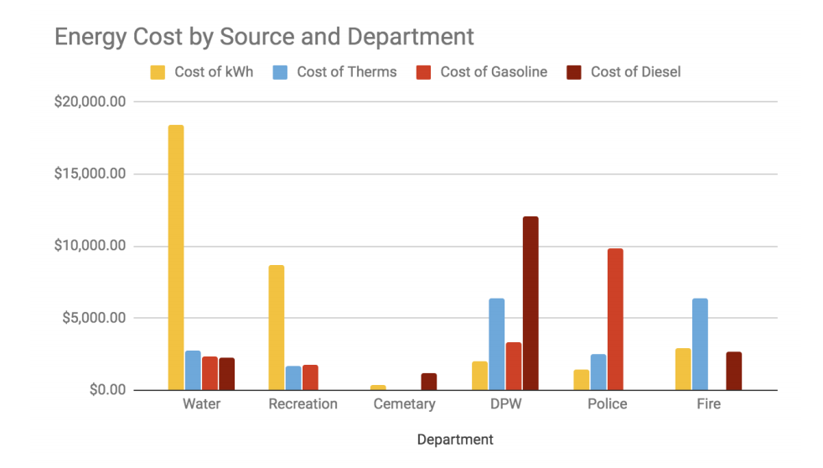
Figure 4

In 2018, total energy costs in Village of Homer was $88,974.44. As is apparent from the graph, the department which spent the most money was the Water Department, which spent about $20,000, and most of its costs were to pay for electricity. The DPW also spent about the same amount of money, most of which was spent for the cost of diesel and natural gas. The public works department spends more than any other department. The graph above shows energy cost by source. Electric costs represent the largest cost to the Village, followed by natural gas, diesel, and finally gasoline.

Building Emissions Data 2017-2018

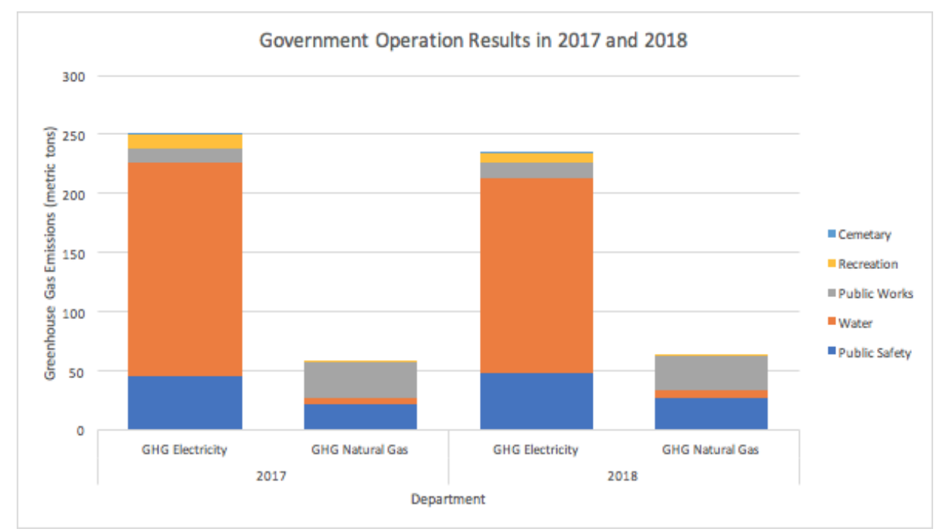
Figure 5

Analyzing the data from 2017 and 2018, it is possible to see what direction the government operations emissions are heading. Some sectors have seen a decrease in emissions, including the water department, which used 8.2% less electricity in 2018 than in 2017. Other departments have used about the same amount of electricity and therefore emitted the same amount of CO2 into the atmosphere. Public Safety, however, used more natural gas in 2018 than 2017 which has contributed to greater total emissions.
Overall, governmental operations emissions from electricity in 2018 decreased by 15 metric tons from 250 metric tons in 2017 to 235 metric tons in 2018. However GHG emissions from heating increased by 5 metric tons in 2018 compared to 2017. As a whole, the government has already made some changes that have contributed to less GHG emissions.

GHG Reduction Targets

Through this climate action plan, the Village of Homer establishes a short term and a long term goal for reducing greenhouse emissions associated with municipal operations. By 2030 we would like to reduce municipal greenhouse gas emissions 30% below 2017 levels. By 2050 we want to reduce municipal greenhouse gas emissions 85% below 2017 levels. This is consistent with the state’s goals regarding emissions reductions. These emissions reductions represent our optimistic goals for the future that are in-line with New York State’s aggressive targets to reduce emissions 40% by 2030 and 85% by 2050, from 1990 levels. The greenhouse gas emissions inventory completed by SUNY ESF students for 2017 will serve as the baseline year for our targets, therefore future greenhouse gas emission reductions will be in comparison to the 2017 results.
We have already begun to address some of the issues within the Village that are causing our emissions. Since the emission inventory was done we have replaced the boiler in the fire department, which was not efficient, with a much more efficient boiler that should significantly reduce the fire departments emissions. The Village has also been working on upgrading all interior lights to LEDs (to be completed in early 2020) and is currently in the process of upgrading streetlights to LEDs (to be completed in late 2020). The village will purchase an electric bike for the police department. This bike will allow the department to use transportation that does not add to the village's emissions. Reducing the Village’s Fleet emissions.
Below we have separated our goals into short and long term, as well as separated specific departments. In each category there are proposed actions for the village to take to achieve our overall goals of 30% reduction by 2030, and 85% by 2050. The lists in each category have the highest priority actions at the top, decreasing priority as the list goes on. It is important to note that these lists are not complete and may change as the Village progresses with certification.

Climate Action Strategies

- Develop Climate Smart Policies: The Village will establish operational policies related to reducing energy consumption and greenhouse gas emissions. This will include developing an anti-idling policy, green building standards for government buildings, a construction and demolition waste policy, an environmentally preferable purchasing policy, and a green power procurement policy. The Village will implement a replacement purchasing policy stating that when equipment, vehicles, and other items reach the end of their life, that they will be replaced with a more efficient and environmentally conscious product. The Village will also establish temperature setpoint policies that state a maximum heating and minimum cooling thermostat setting for all buildings. In collaboration with the climate smart communities task force, the Village will research similar policies adopted by other municipalities to identify policies that could be adapted for the Village of Homer.

- Conduct Comprehensive Energy Audit: The Village will work with consulting engineers to conduct a detailed ASHRAE Level 2 energy audit of all municipal buildings to identify potential cost-saving and energy efficiency measures. This will include an analysis of HVAC equipment, lighting, building envelopes, water pumps, and other systems to determine whether more efficient equipment could be installed to achieve cost reductions and energy savings.

- Improve Water Department Efficiency: The Village will conduct an analysis to identify opportunities for reducing energy consumption in the Water Department, which has the highest energy consumption and greenhouse gas emissions of any Village department. This will include determining whether pump motors can be replaced with smaller sized motors, replacing water pump motors with premium efficiency motors, and installing Variable Frequency Drives (VFDs) on pump motors, which adjust pump speed based on pumping need. The Village will also identify opportunities for reducing water demand in the village, such as organizing a water conservation campaign to reduce the water consumption of Village businesses and residents.

- Install Efficient Lighting Controls: The Village will install lighting controls, such as timers, occupancy sensors, and photo sensors, to reduce lighting run-hours.

- Increase Renewable Energy and Electrification: The Village will explore the feasibility of transitioning to renewable energy such as solar and wind through onsite renewables, power purchase agreements, Renewable Energy Certificates (RECs), and community solar. The Village will seek to expand the procurement of renewable energy in order to stay in line with New York’s commitment to have 70% renewable energy by 2030 and 100% by 2050. The Village will also explore the feasibility of transitioning away from natural gas heating through highly efficient geothermal systems and air-source heat pumps. Switching to electric heat pumps combined with renewable energy will eliminate a significant portion of municipal greenhouse gas emissions.

- Purchase Fuel Efficient and Alternative Fuel Vehicles: The Village will explore the feasibility of utilizing alternative fuel vehicles (hybrids, plug-in hybrids, plug-in electric vehicles, compressed natural gas, etc.) in order to reduce gasoline and diesel fuel consumption. The Village will consider fuel efficiency ratings and alternative fuel vehicles when making purchasing decisions including police vehicles, heavy duty trucks, and other vehicles. The Village will also explore opportunities for reducing vehicle miles traveled of fleet vehicles.

- Engage Village Employees with Climate Action: The Village will develop a plan to engage Village of Homer employees with greenhouse gas emission reduction goals. This may include training, soliciting ideas for saving energy, and coordinating a behavior change campaign to encourage energy conservation.

- Improve Plug Load Energy Conservation: The Village will identify opportunities to reduce energy consumption related to plug load such as enabling the sleep mode on computers, monitors, printers, copiers, and other office devices; and turning off equipment at the end of the work day.

- Community Climate Action and Resiliency Planning: The Village will incorporate climate change mitigation and resiliency into municipal planning including the Comprehensive Plan. The Village will conduct a community greenhouse gas emission inventory and develop a community climate action plan, which will inform the development of the municipal Comprehensive Plan. The Village will take steps to promote walking and bicycling within the village by expanding sidewalks to connect neighborhoods to the village center and exploring other methods of developing “complete streets” to promote alternative transportation within the village. The Village will conduct a climate vulnerability assessment to identify potential risks associated with the impacts of climate change and will develop a resiliency plan to mitigate those risks.

Ongoing GHG Monitoring and CAP Updates

The Village of Homer will complete a municipal greenhouse gas emission inventory annually and provide a progress report annually. This will be performed by a combination of village employees and the Climate Smart Communities (CSC) Task Force. The Village’s account clerk, Danna Kotas, will keep a running total of the number of kWh of electricity, therms of natural gas, and gallons of fuel (diesel and / or gasoline) consumed by the village each year. The CSC Task Force will convert this information into tons of CO₂ emissions on a yearly basis to track our progress toward the reduction goals outlined above.
Every five years, the CSC Task Force will use this yearly compiled data to review and update this action plan. This should be a living document that changes to reflect our continued progress in reducing greenhouse gas emissions. Updates may include, but are not limited to:
- Additional tables, graphs, etc to display the trend of greenhouse gas emissions since this plan was adopted.
- Adding or adjusting short and long term action items to meet future plans and goals.
- Updating targets to reflect potential changes in New York State’s emission goals.
- Other changes or adjustments to reflect the village government and CSC Task Force’s vision for emissions reductions.
Revisions and updates to the Climate Action Plan should be presented by the CSC Task Force to the village board and approved by both bodies before being acted on.

